Template for extended abstract – to be removed
<Provide Title Of The Paper Here>
[Times New Roman-12-bold/Caps]

A.B. Firstauthor*, C. Coauthor** and D.E. Other coauthor†*

* Institution/Department, Affiliation, City, Country*
** Institution/Department, Affiliation, City, Country*
†Institution/Department, Affiliation, City, Country*

Abstract

Instructions for preparing extended one page abstract for symposium are presented. They are intended to guide the authors in preparing camera-ready hardcopy and electronic form of their papers. Provide an abstract of the paper (10 point bold) no longer than 200 words. Do not indent any part of the abstract.*[Times New Roman-10]

Introduction

English is the official language of the symposium. Please submit 1 page extended abstract for the consideration of symposium participation. The authors are responsible for the content and originality. Give an introduction to the work presented in the paper [Times New Roman-10]

Materials and Methods or pedagogy

Keywords: Five to ten keywords of the manuscript should be placed beneath the abstract. Put a comma after each keyword and type them in lower-case except for special cases such as abbreviations. [Times New Roman-10, Italic face]
Style: Use separate sections for introduction, materials and methods, results, discussion, conclusions, acknowledgements (when appropriate), Non technical papers on educational pedagogy should provide information on methodology and related processes in implementation. Type the section headings in bold style without indentation and leave one blank line before and after each heading. Use only one level of headings.
Body Text: Use Roman typeface (10 point regular) throughout. Only if you want to emphasise special parts of the text use Italics. Start a new paragraph by indenting it from the left margin by 5 mm (and not by inserting a blank line).
Tables and Figures: Paste tables and figures where needed (as close as possible to where they are mentioned in the text), if necessary spanning both columns. Number them consecutively using Arabic numbers (e.g. Table 1, Table 2, Figure 1, Figure 2,) and provide a caption for each table and figure. Place captions above the tables and beneath the figures. Leave one blank line before, and one after the captions. Do not indent or center the captions. Please keep in mind the distinction between tables and figures: tables only contain alphanumerical characters and no graphical elements.

Table 1. Parameters
Specifications | Notation | Estimated value
Delay time [s] | δ | 0.1
Time Constant [s] | τ | 0.2
Time constant [s] | ζ | 0.3
Feed-forward gain | γ | 0.4
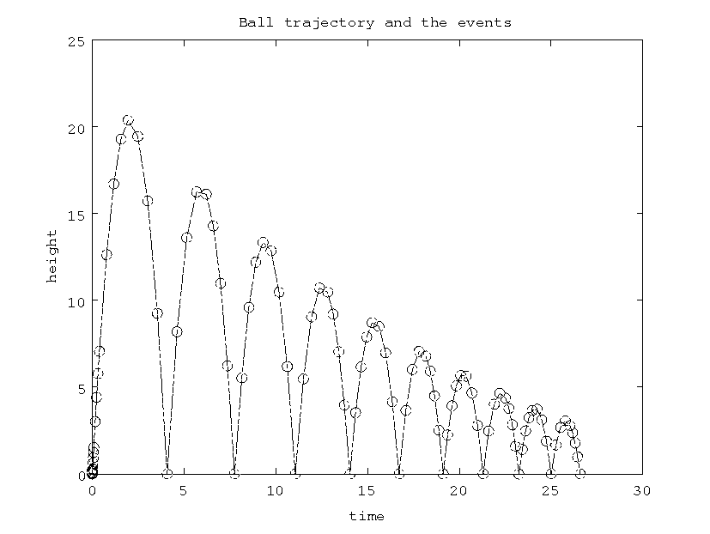

Figure 1. Sample figure

Results and Discussion

Remember to discuss the findings of the paper in order to know the outcome of the work. Remember the ‘golden rules’: Please do not end a page with a heading; do not start a page with an incomplete line; do not underline any part of the text; do not forget to check the spelling.

Conclusions

Remember to conclude the paper with your findings and preliminary result in order to know the final outcome of the work .

Acknowledgements

You may acknowledge (when appropriate) the organisations who have funded or extended their facilities for doing the research work.

